(Q) What is class? It is blueprint to create a object

(Q) What is Object? It is real world entity/data which takes memory

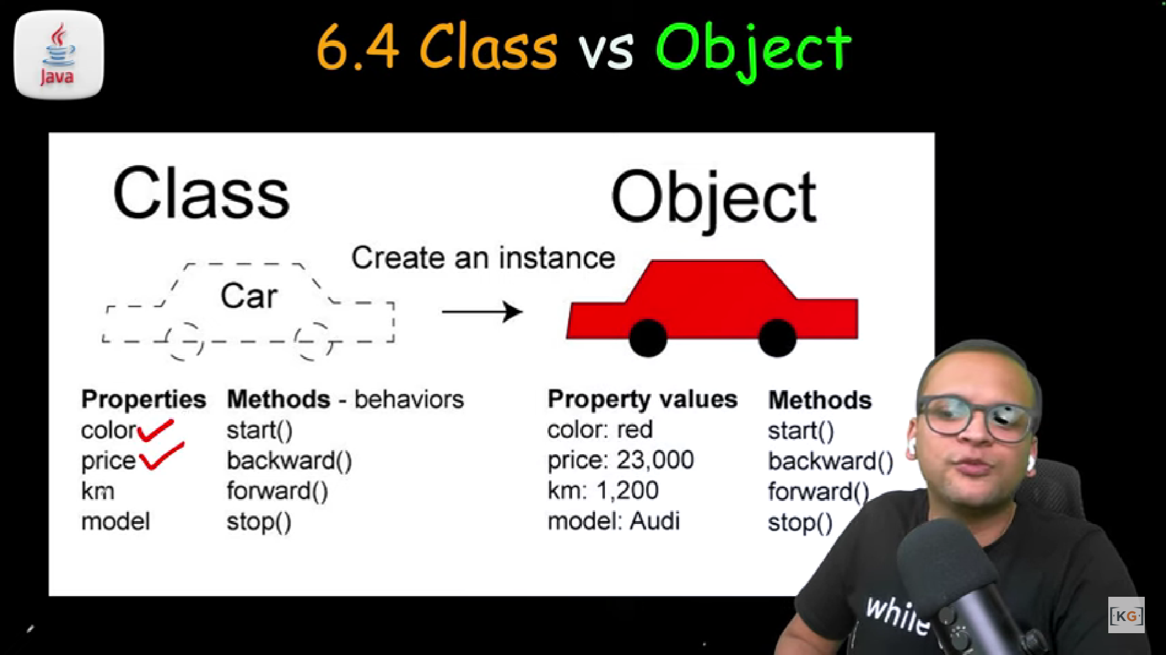

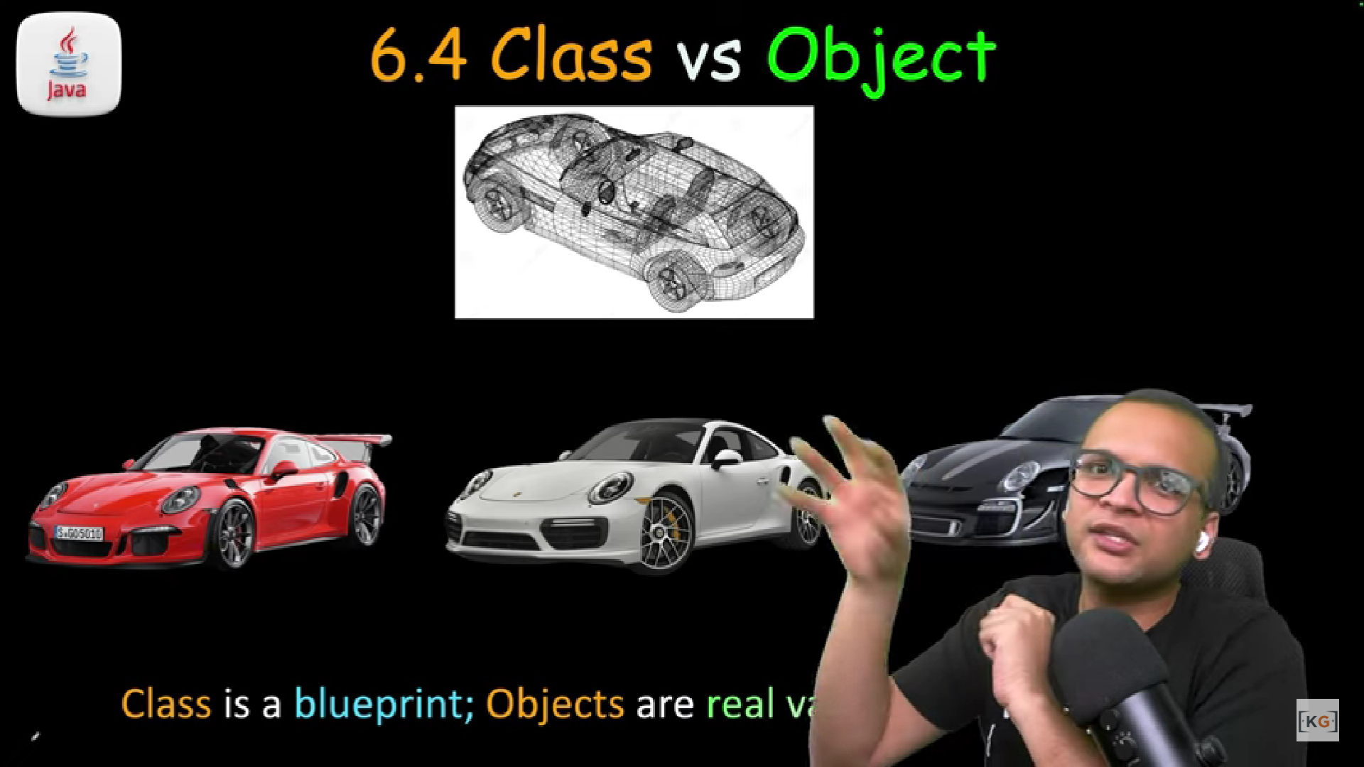

(Q) this keyword? It repersent current object. If local variable in a method and instance/class level variable name is same than we use this to resolve conflict

(Q) static keyword? If some property and method/behaviour is not specific to object. In other words common for all it’s objects than we should declare it as static. To access static field we do not need to create object just class name is enough.

Static variable/method can be accessed from non static area but static method or variable can not access non static method/variable.

(Q) Constructor? Default value के साथ Object के state को initialize करने के लिए use होता है

(Q) Stack vs Heap memory?

All primitives stay in Stack memory. All Objects lives in Heap memory. Stack points to heap.

(Q) Garbage Collection ? Automatic process managed by JVM. Any object which is not pointed by stack memory is illegible for GC. It clears Heap memory